**ArubaEZ – Promo code Reactivation to Default**

To perform any Live price call, below parameters would be send as an Input parameter

1. Account Number
2. Item Code
3. UOM
4. Promo code

For ArubaEZ, **“EZ”** is the default value for any live price call

Please find below illustrations/screenshots showing results of the Live pricing by sending with or without default value to the promo code

1. Search for the item with item code **9004709** and with promocode as **“EZ”**

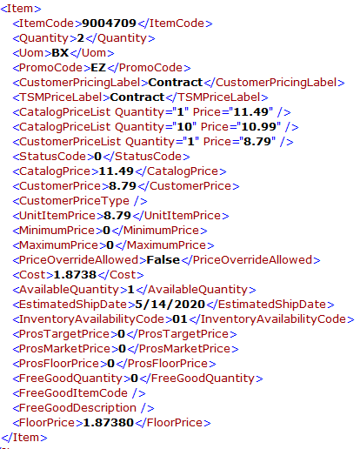

1. Search for the item with item code **9004709** and with promocode as “ ”i.e. Empty

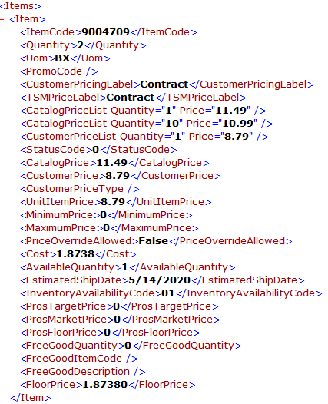

1. Search for the item with item code **1000213** and with promocode as “**EZ**”

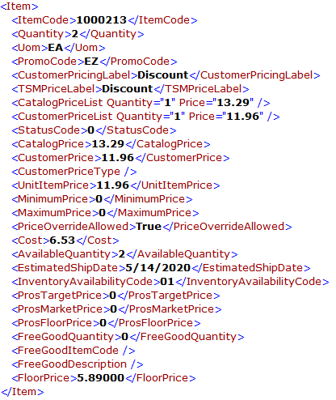

1. Search for the item with item code **1000213** and with promocode as “”

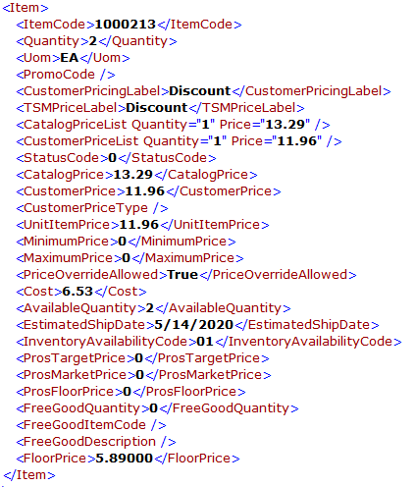

1. Search for the item with item code **1009338** and with promocode as “**EZ**”

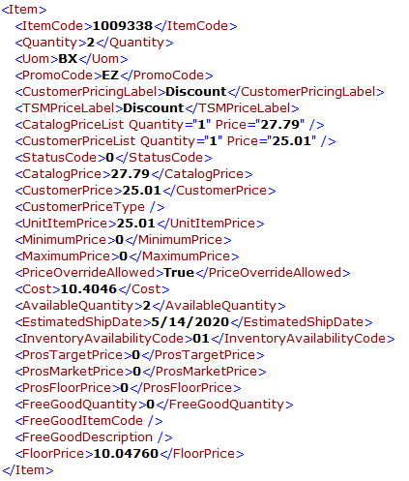

1. Search for the item with item code **1009338** and with promocode as “”

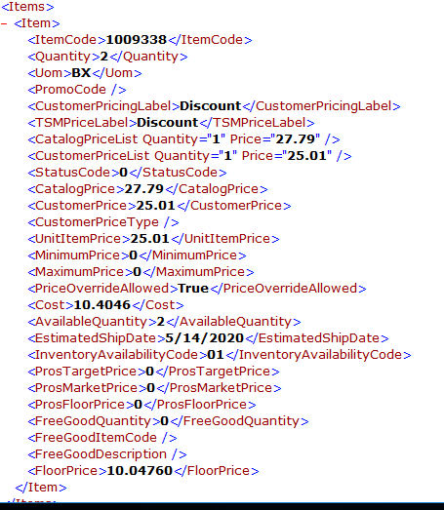

<EOD>